**EXPENSE TRACKER**

Sprint 1 and Sprint 2

***Submitted by***

BL.EN.U4CSE19091 - N.KAVYA REDDY

BL.EN.U4CSE19110 - M.PREETHI REDDY

BL.EN.U4CSE19140 - V.SHRAVYA

BL.EN.U4CSE19154 – Y.SRAVYA REDDY

***In partial fulfilment of the requirements for the completion of Agile Use cases for***

**Project-based Course**

**19CSE19314 – SOFTWARE ENGINEERING**



AMRITA SCHOOL OF ENGINEERING, BENGALURU

AMRITA VISHWA VIDYAPEETHAM

**BENGALURU 560035**

May-2022

# **EXPENSE TRACKER SPRINT REPORT**

# Sprint 1 - Ending April 24,2022

# Sprint 2 - Ending May 13 ,2022

## **Context**

First Day of Sprint 1: March 28, 2022

Last Day of Sprint 1: April 24, 2022

First Day of Sprint 2: April 25, 2022

Last Day of Sprint 2: May 13, 2022

Working Days in Sprint 1: 23

Working Days in Sprint 2: 14

### **TEAM MEMBERS**

The following cross-functionality team members participated in the sprint. Also listed are the days they were expected to work and the number of days they did work.

| **Name** | **Role in the Sprint** | **Planned Days** | **Worked Days** |
| --- | --- | --- | --- |
| Y. Sravya Reddy | Scrum Master | **10** | **8** |
| N. Kavya Reddy | Developer | **10** | **9** |
| M. Preethi Reddy | Product owner | **10** | **8** |
| V. Shravya | Developer | **10** | **9** |

**Sprint 1 and Sprint 2 Sprint 1 and Sprint 2**

**Internal Assessor Product Owner**

## **1.USER STORIES**

**SPRINT 1**

|  |  |  |  |
| --- | --- | --- | --- |
| User Story ID | As a *<type of user>* | I want to *<perform some task>* | so that I can *<achieve some goal>* |
| 1 | user | I should be able to open the webpage of expense tracker | so that I can use the expense tracker application |
| 2 | user | I should be able to login/register | so that I can use the expense tracker application |
| 3 | user | I should be able to reset my password | so that I can log into my account if I forget my password |
| 4 | user | I should be able to edit the information in my profile | so that I can change my details |
| 5 | user | I should be able to add categories and edit both categories and their limits | so that I can modify data according to my needs |
| 6 | user | I want to see the transaction analysis in a particular period of time | so I can analyse how I have been spending |
| 7 | user | I should receive alert notifications for categories | so that I can be well informed about my transactions |
| 8 | user | Log out account | Log out my account conveniently if I am not interested |
| 9 | scrum master | track and report the progress of the team | ensure the project stays on track |
| 10 | product owner | maintain the product backlog | clearly document the product requirements |
| 11 | analyst | gather, interpret and analyse the data | check for any improvements if required |
| 12 | front-end developer | create a user-interface | provide a user-friendly experience for those using the interface |

**SPRINT 2**

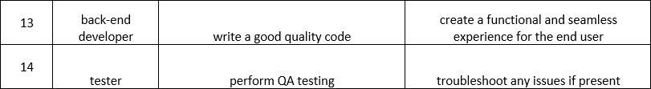

## **2.PRODUCT BACKLOGS**

**SPRINT 1**

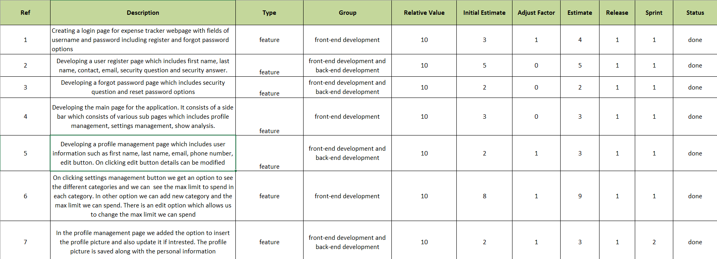

**SPRINT 2**

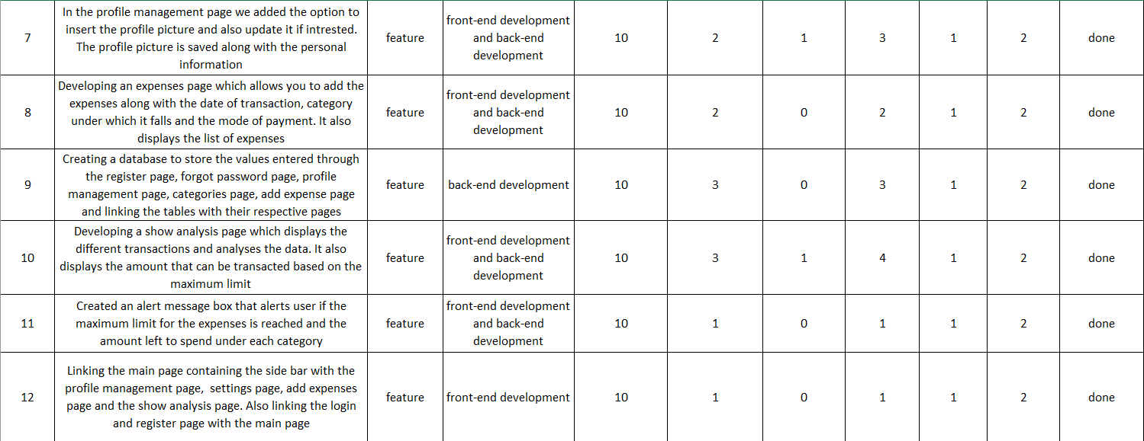

## **3.ITERATION PLANNING**

**SPRINT 1**

**ITERATION 1**

* Introduction Managing header functions
* Vision and Roadmap To manage the header functions
* Number of user stories fit 7
* Current Status Resolved
* Iteration Theme / Name header function management
* Prior Data changing profile details
* Dates 28-03-2022 to 15-04-2022
* Capacity 7
* Issues / Logistics Debugging errors after edited
* DOD 15-04-2022
* Backlog Extract Updated
* Tasking users can login and edit their profile
* Issues and Risks Debugging errors after editing profile
* Dependencies and Assumptions Using profile details to achieve better usage
* “Commitment” Complete a given module in specified period of time
* Actions Enables the user to login and change profile details
* Retrospect Creation of frontend, back end, testing and debugging

Provide a range estimate for how long each selected activity will take for your team.

Total 7

**ITERATION 2**

* Introduction Managing login functions
* Vision and Roadmap To manage the login functions
* Number of user stories fit 4
* Current Status Resolved
* Iteration Theme / Name login function management
* Prior Data changing login details
* Dates 28-03-2022 to 6-04-2022
* Capacity 4
* Issues / Logistics Debugging errors after edited
* DOD 6-04-2022
* Backlog Extract Updated
* Tasking users can login and change their login details
* Issues and Risks Debugging errors after editing profile
* Dependencies and Assumptions Using login details to use the expense tracker
* “Commitment” Complete a given module in specified period of time
* Actions Enables the user to login or change login details
* Retrospect Creation of frontend, back end, testing and debugging

Provide a range estimate for how long each selected activity will take for your team.

Total 8

**ITERATION 3**

* Introduction Managing profile management functions
* Vision and Roadmap To manage the profile management functions
* Number of user stories fit 1
* Current Status Resolved
* Iteration Theme / Name login function management
* Prior Data changing login details
* Dates 14-04-2022 to 15-04-2022
* Capacity 1
* Issues / Logistics Debugging errors after edited
* DOD 15-04-2022
* Backlog Extract Updated
* Tasking users can change their profile details
* Issues and Risks Debugging errors after editing profile
* Dependencies and Assumptions Using profile details to achieve better usage
* “Commitment” Complete a given module in specified period of time
* Actions Enables the user to change profile details
* Retrospect Creation of frontend, back end, testing and debugging

Provide a range estimate for how long each selected activity will take for your team.

Total 1

**ITERATION 4**

* Introduction Managing settings management functions
* Vision and Roadmap To manage the settings management functions
* Number of user stories fit 1
* Current Status Resolved
* Iteration Theme / Name settings function management
* Prior Data changing expense categories details
* Dates 17-04-2022 to 24-04-2022
* Capacity 1
* Issues / Logistics Debugging errors after edited
* DOD 24-04-2022
* Backlog Extract Updated
* Tasking users can change their expense categories details
* Issues and Risks Debugging errors after editing settings
* Dependencies and Assumptions Using settings details to add user interested categories
* “Commitment” Complete a given module in specified period of time
* Actions Enables the user to add user interested categories
* Retrospect Creation of frontend, back end, testing and debugging

Provide a range estimate for how long each selected activity will take for your team.

Total 1

**SPRINT 2**

**ITERATION 5**

* Introduction Managing show analysis functions
* Vision and Roadmap To manage the show analysis functions
* Number of user stories fit 2
* Current Status Resolved
* Iteration Theme / Name show analysis function management
* Prior Data show transaction analysis
* Dates 4-05-2022 to 6-05-2022
* Capacity 2
* Issues / Logistics Debugging errors after edited
* DOD 6-05-2022
* Backlog Extract Updated
* Tasking users can see their expense transaction details
* Issues and Risks Debugging errors after showing analysis
* Dependencies and Assumptions Using settings details to see the transaction summary
* “Commitment” Complete a given module in specified period of time
* Actions Enables the user to see the transaction summary
* Retrospect Creation of frontend, back end, testing and debugging

Provide a range estimate for how long each selected activity will take for your team.

Total 2

**ITERATION 6**

* Introduction Managing alert functions
* Vision and Roadmap To manage the alert functions
* Number of user stories fit 2
* Current Status Resolved
* Iteration Theme / Name alert function management
* Prior Data show alert function
* Dates 9-05-2022 to 9-05-2022
* Capacity 1
* Issues / Logistics Debugging errors after edited
* DOD 9-05-2022
* Backlog Extract Updated
* Tasking users can see alerts if the transaction exceeds limit
* Issues and Risks Debugging errors after showing alerts
* Dependencies and Assumptions Using alert function to see if the transaction exceeds limit
* “Commitment” Complete a given module in specified period of time
* Actions Enables the user to see if the transaction exceeds limit
* Retrospect Creation of frontend, back end, testing and debugging

Provide a range estimate for how long each selected activity will take for your team.

Total 1

## **1.DAILY SCRUM REPORT**

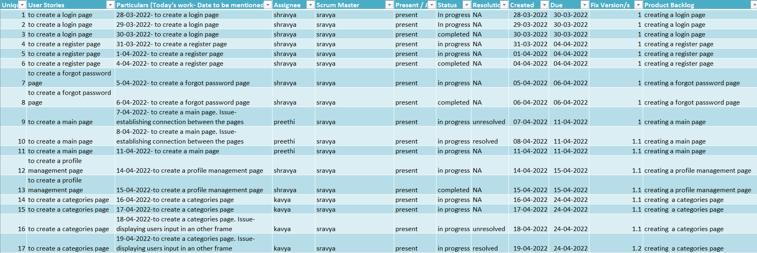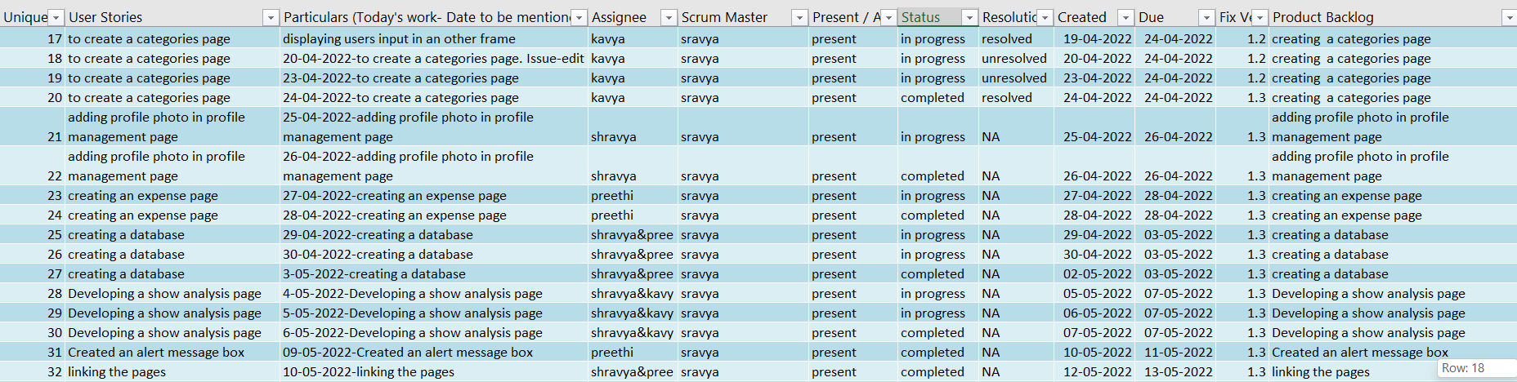

## **2.TEST CASES FOR SPRINT 1**

|  |  |  |  |  |  |  |  |
| --- | --- | --- | --- | --- | --- | --- | --- |
| **Project Name: Expense Tracker application** | | | | | | | |
| **Test Case Template** | | | | | | | |
| **Test Case ID: Func_1** | | | | **Test Designed by: <Sravya>** | | | |
| **Test Priority (Low/Medium/High): Med** | | | | **Test Designed date: <28-03-2022>** | | | |
| **Module Name: Login Screen** | | | | **Test Executed by: <Preethi>** | | | |
| **Test Title: Verify login with valid username and password** | | | | **Test Execution date: <30-04-2022>** | | | |
| **Description: Test the login page** | | | |  | | | |
| **Pre-conditions: User has valid username and password** | | | | | | | |
| **Dependencies:** | | | | | | | |
| **Step** | **Test Steps** | **Test Data** | **Expected Result** | | **Actual Result** | **Status (Pass/Fail)** | **Notes** |
|  | Navigate to login page | User= [shravya70@gmail.com](mailto:example@gmail.com) | User should be able to login | | User is navigated to home page after logging in | Pass |
| 1 |  |
| 2 | Provide valid username | Password: 1234 |  | | dashboard with successful |  |  |
| 3 | Provide valid password |  |  | | Login |  |  |
| 4 | Click on Login button |  |  | |  |  |  |
| **Post –Conditions:** | | | | | | | |
| User is validated with database and successfully login to account. The account session details are logged in database | | | | | | | |

|  |  |  |  |  |  |  |  |
| --- | --- | --- | --- | --- | --- | --- | --- |
| **Project Name: Expense Tracker application** | | | | | | | |
| **Test Case Template** | | | | | | | |
| **Test Case ID: Func_2** | | | | **Test Designed by: <Sravya>** | | | |
| **Test Priority (Low/Medium/High): Med** | | | | **Test Designed date: <14-03-2022>** | | | |
| **Module Name: Edit Profile** | | | | **Test Executed by: <Shravya >** | | | |
| **Test Title: Profile Management page** | | | | **Test Execution date: <15-04-2022>** | | | |
| **Description: Edit the Profile page** | | | |  | | | |
| **Pre-conditions: User has valid username and password** | | | | | | | |
| **Dependencies:** | | | | | | | |
| **Step** | **Test Steps** | **Test Data** | **Expected Result** | | **Actual Result** | **Status (Pass/Fail)** | **Notes** |
|  | Navigate to profile management page | Username= [shravya70@gmail.com](mailto:example@gmail.com) | User should be able to edit profile page | | User can edit details in profile page | Pass |
| 1 |  |
| 2 | Add a profile photo |  |  | |  |  |  |
| 3 | Change email |  |  | |  |  |  |
| 4 | Change phone number | Change profile photo |  | | dashboard with successful |  |  |
| **Post –Conditions:** | | | | | | | |
| User is validated with database and successfully login to account. The account session details are logged in database | | | | | | | |

## **2. TEST CASES FOR SPRINT 2**

|  |  |  |  |  |  |  |  |
| --- | --- | --- | --- | --- | --- | --- | --- |
| **Project Name: Expense Tracker application** | | | | | | | |
| **Test Case Template** | | | | | | | |
| **Test Case ID: Func_3** | | | | **Test Designed by: <Sravya>** | | | |
| **Test Priority (Low/Medium/High): Med** | | | | **Test Designed date: <04-05-2022>** | | | |
| **Module Name: Show Analysis page** | | | | **Test Executed by: <Kavya>** | | | |
| **Test Title: Transaction Analysis** | | | | **Test Execution date: <06-05-2022>** | | | |
| **Description: Shows Transaction Analysis of user** | | | |  | | | |
| **Pre-conditions: User has valid username and password** | | | | | | | |
| **Dependencies:** | | | | | | | |
| **Step** | **Test Steps** | **Test Data** | **Expected Result** | | **Actual Result** | **Status (Pass/Fail)** | **Notes** |
|  | Navigate to show analysis page | Select date- ex-10-05-2022 to 15-05-2022 | User should be able to see the analysis | | User can see the transaction analysis | Pass |
| 1 |  |
| 2 | Provide valid username | Password: 1234 |  | | dashboard with successful |  |  |
| **Post –Conditions:** | | | | | | | |
| User is validated with database and successfully login to account. The account session details are logged in database | | | | | | | |
|  | | | | | | | |

## **1.CONTENTS AND ASSESMENT**

Points Planned: 7

Points Earned: 6

| **Story** | **Points** | **Result** |
| --- | --- | --- |
| Create an account and update user’s details | **2** | **Finished** |
| Change the details in the user’s profile | **1** | **Finished** |
| Add transactions in the account | **2** | **Finished** |
| Add categories | **1** | **Finished** |
| See the transaction analysis | **1** | **Finished** |
|  |  |  |

### **1.SPRINT CODE**

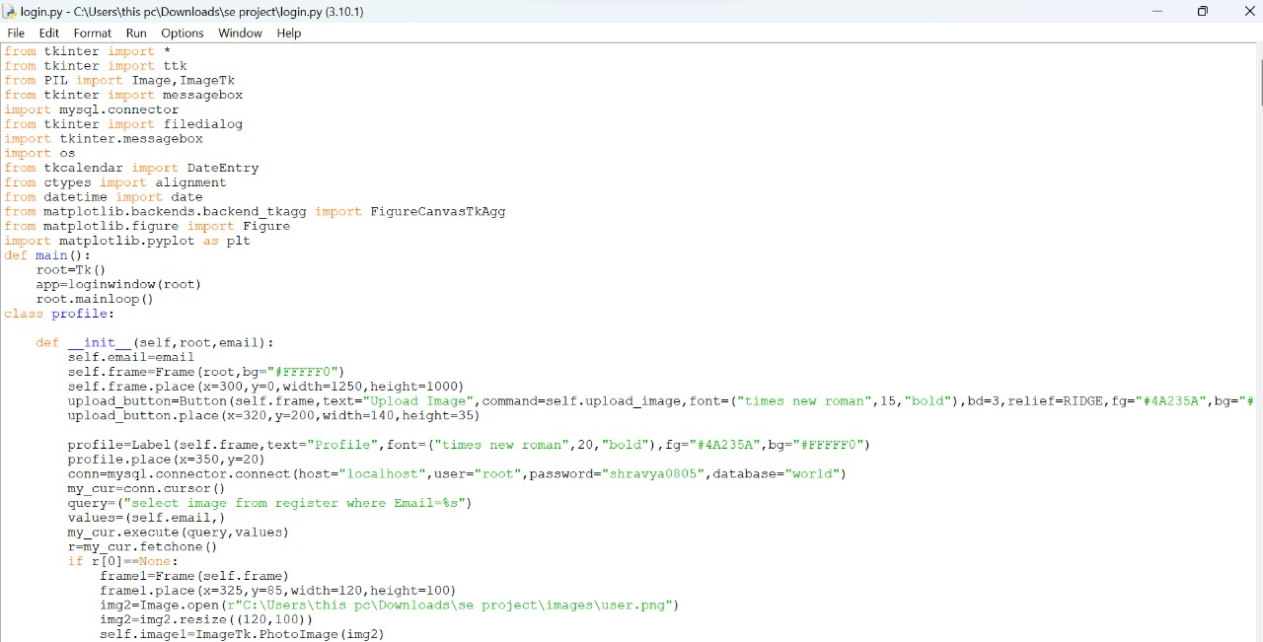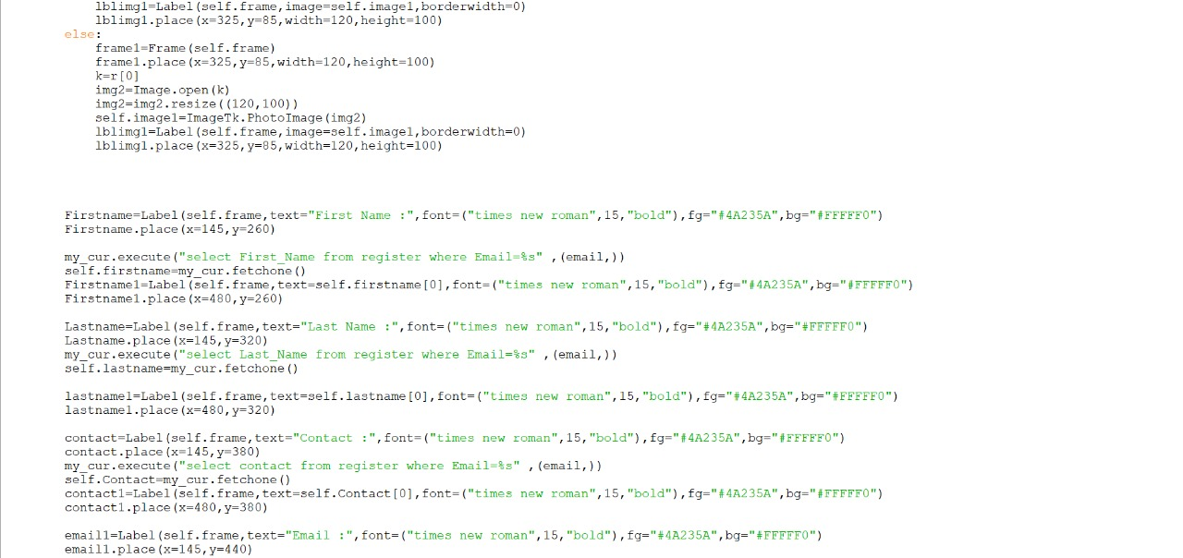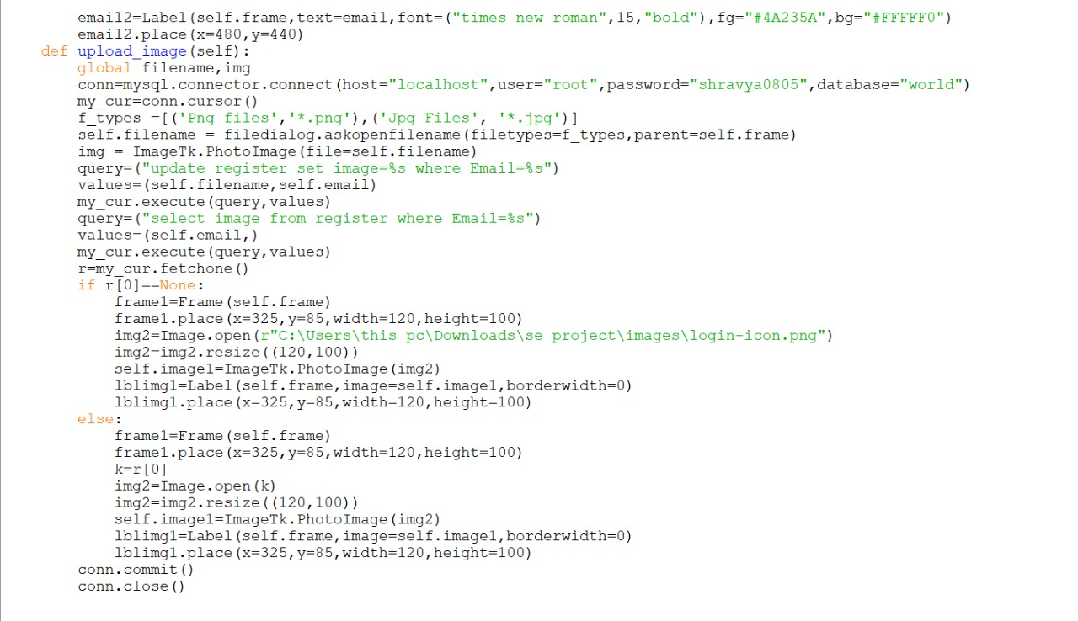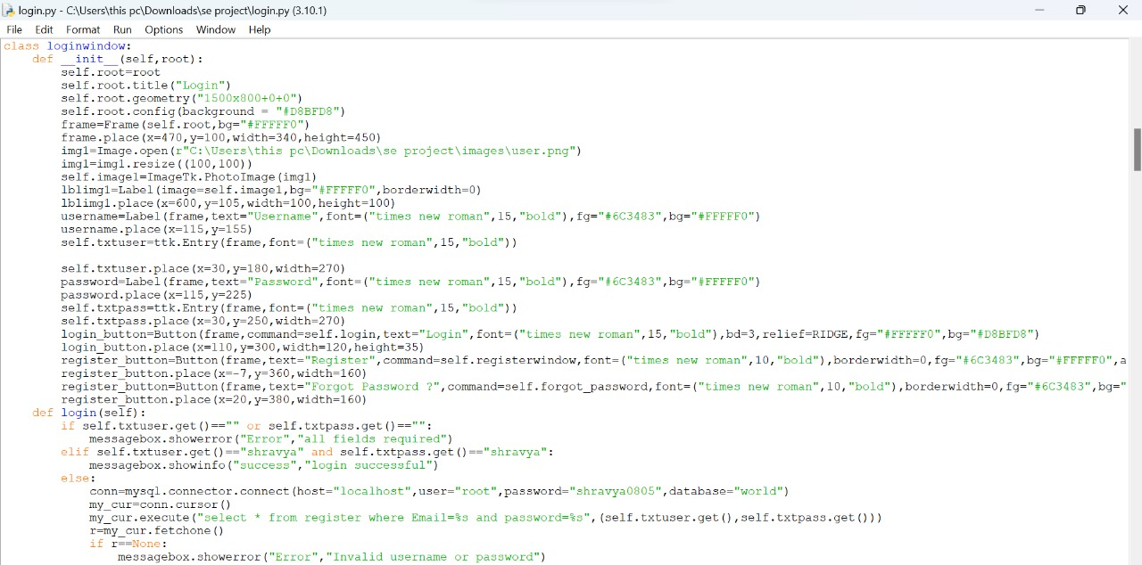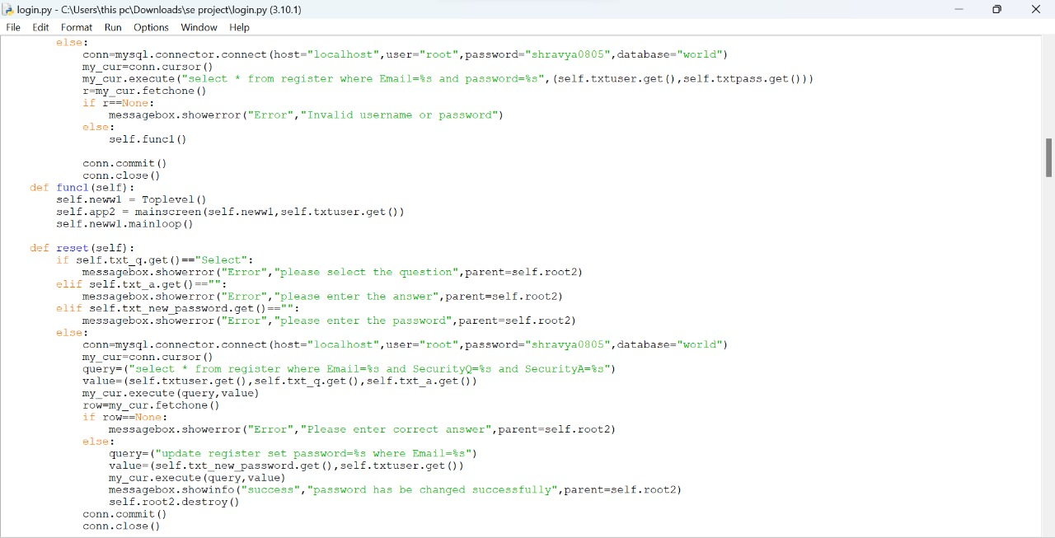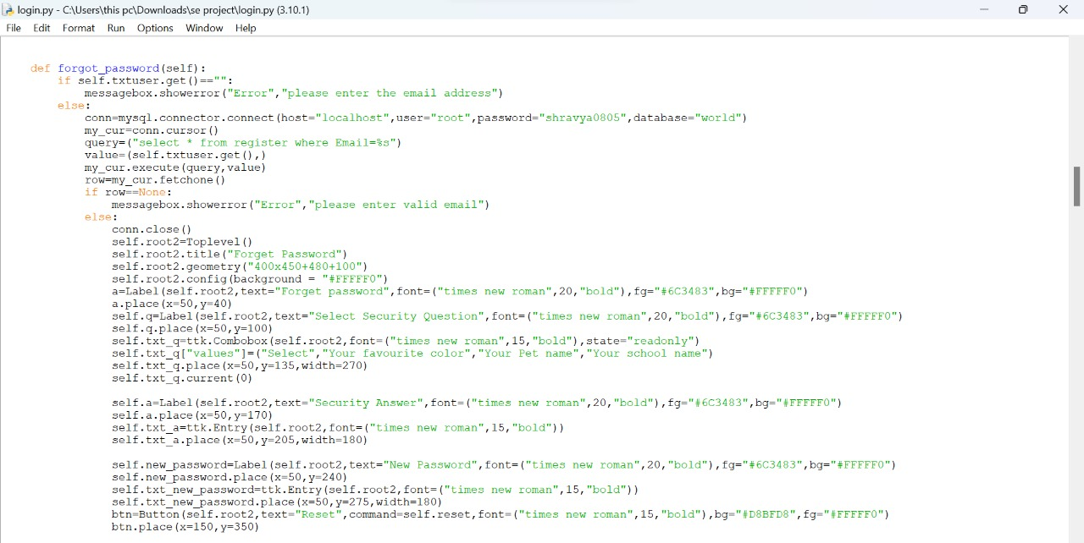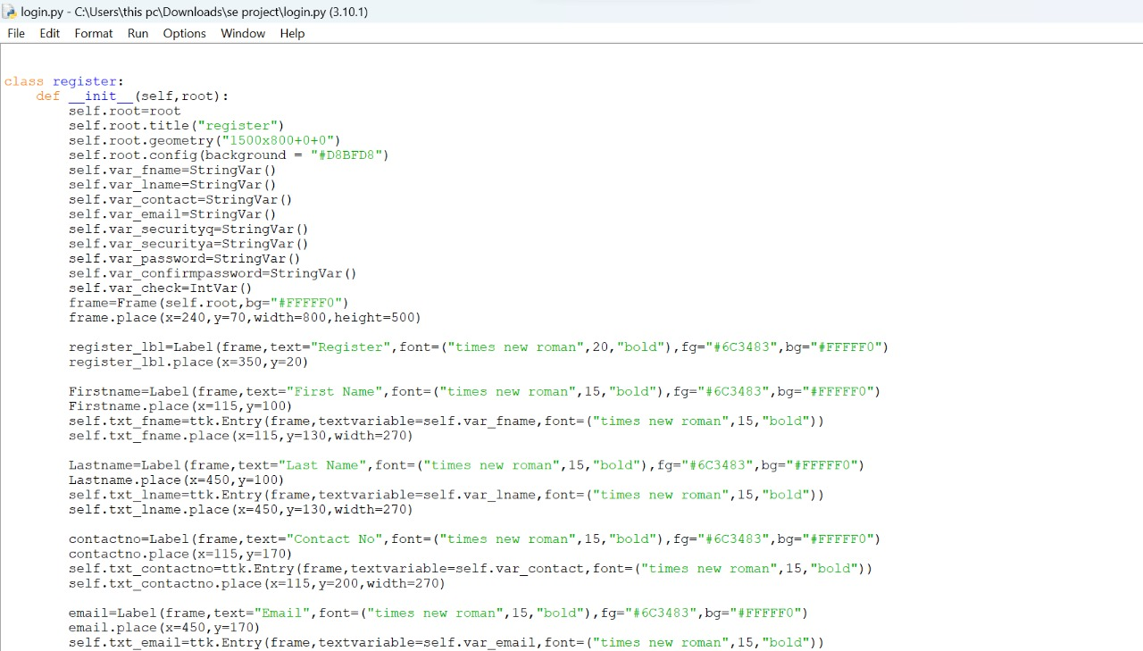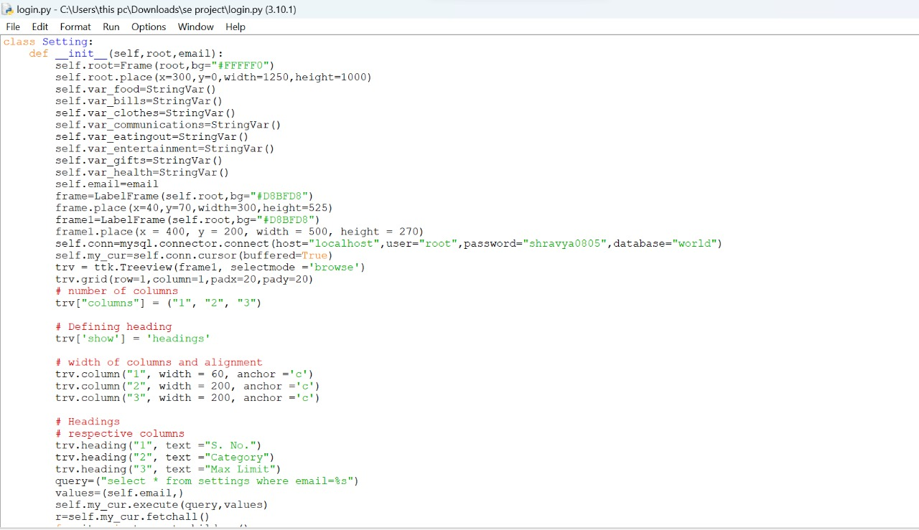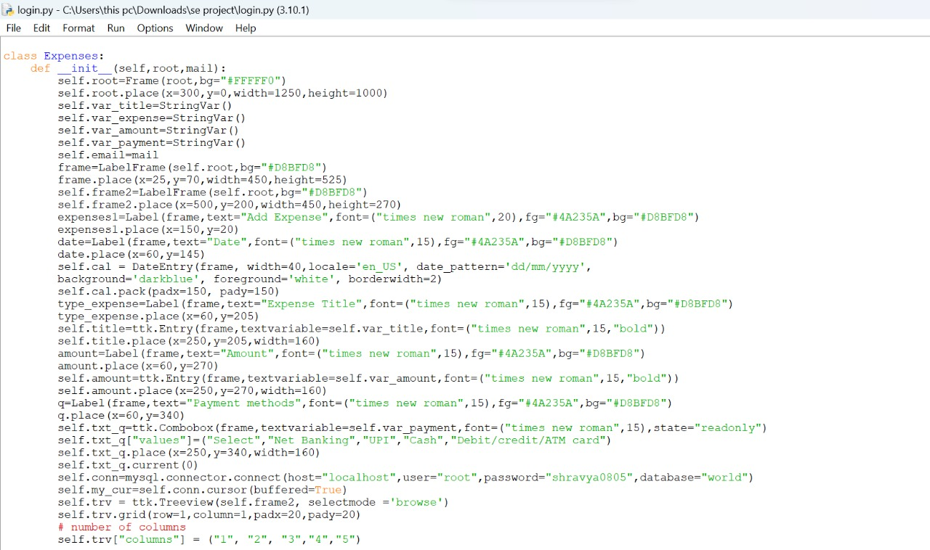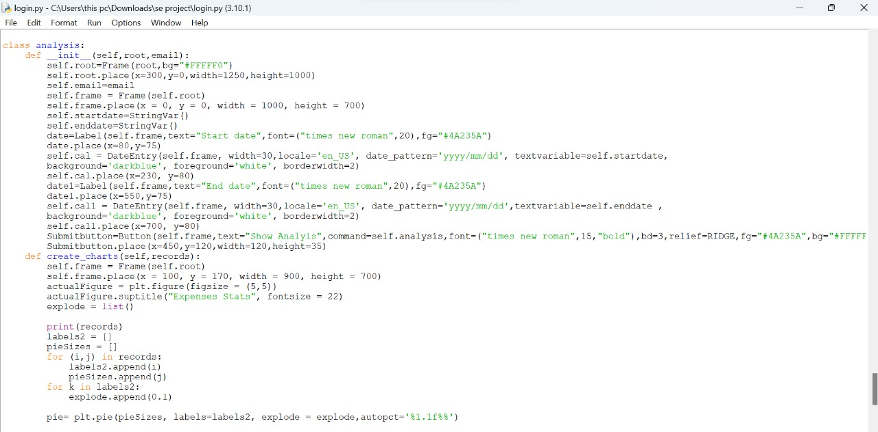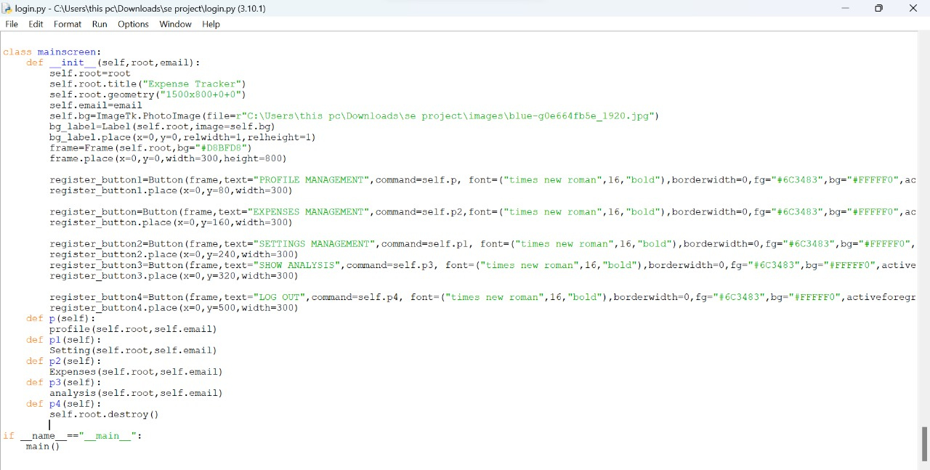

### **2.SPRINT IMPLEMENTATION**

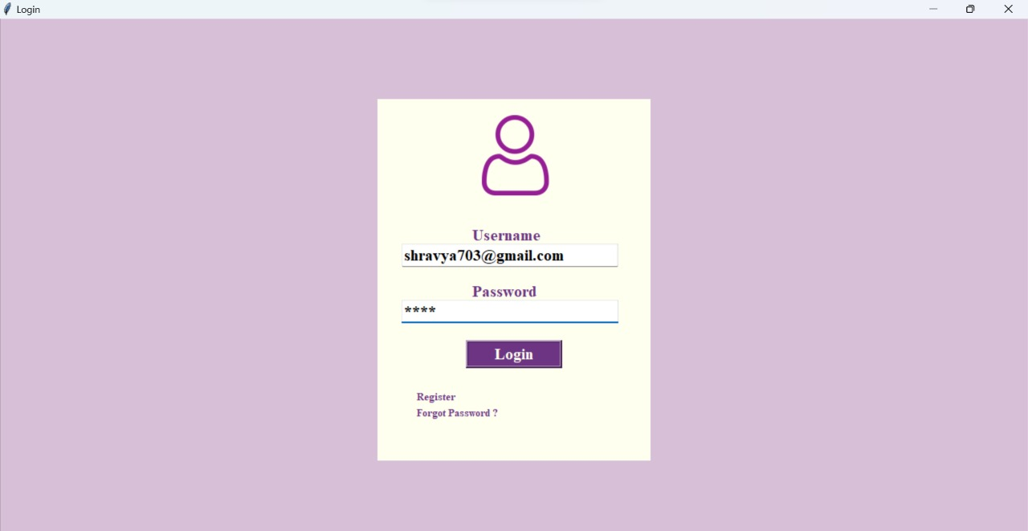

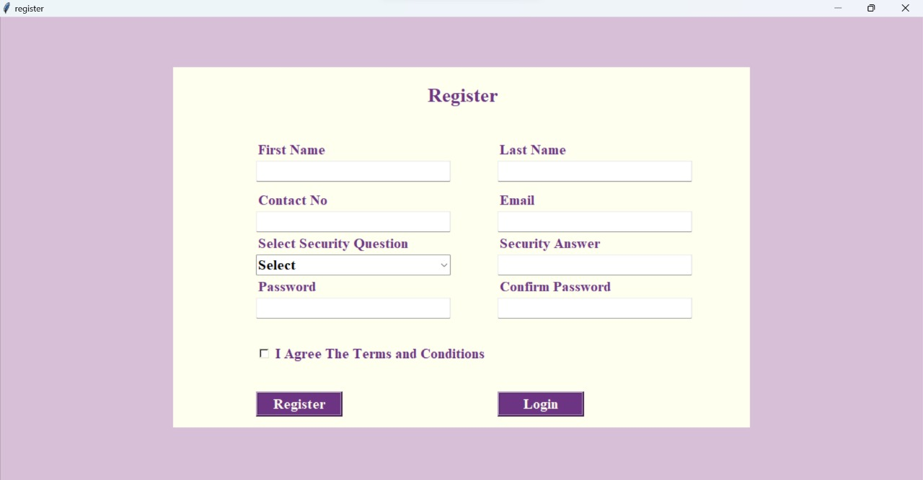

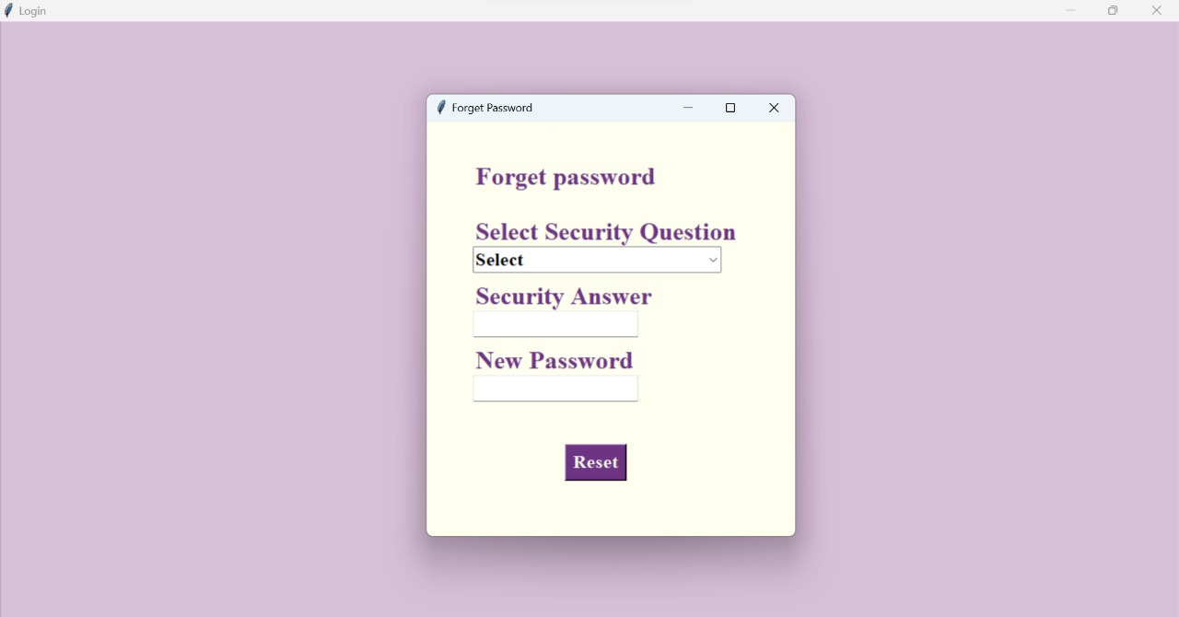

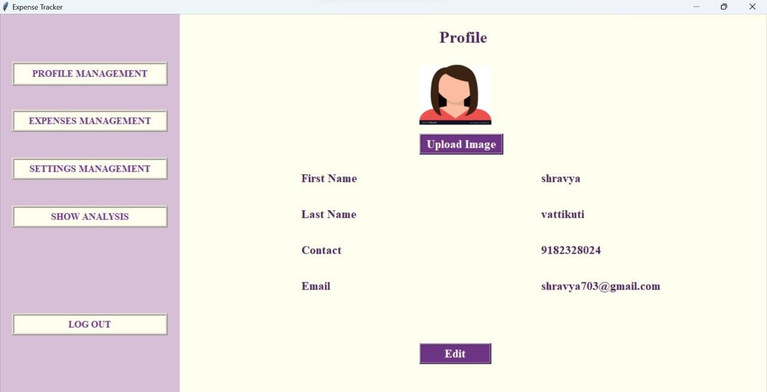

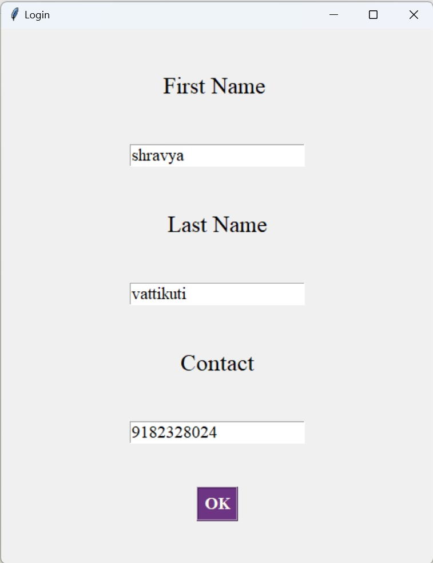

z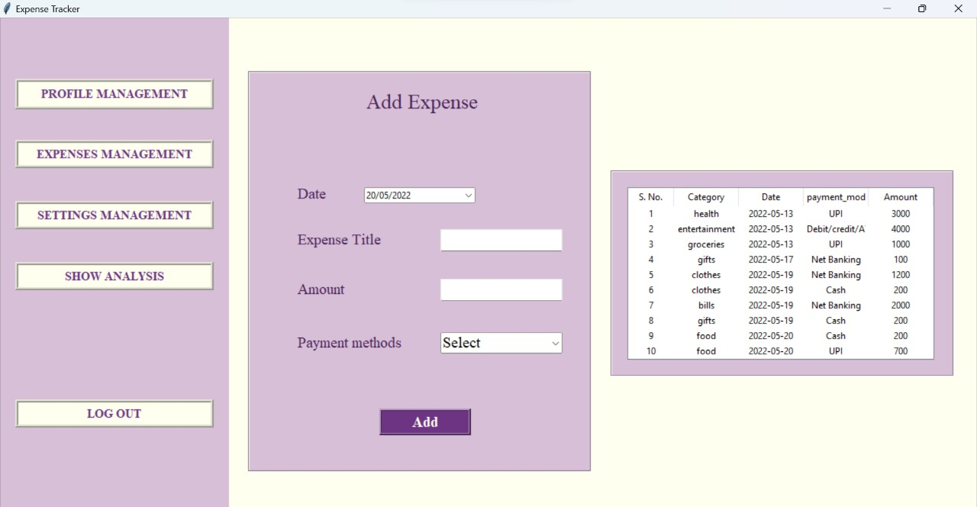

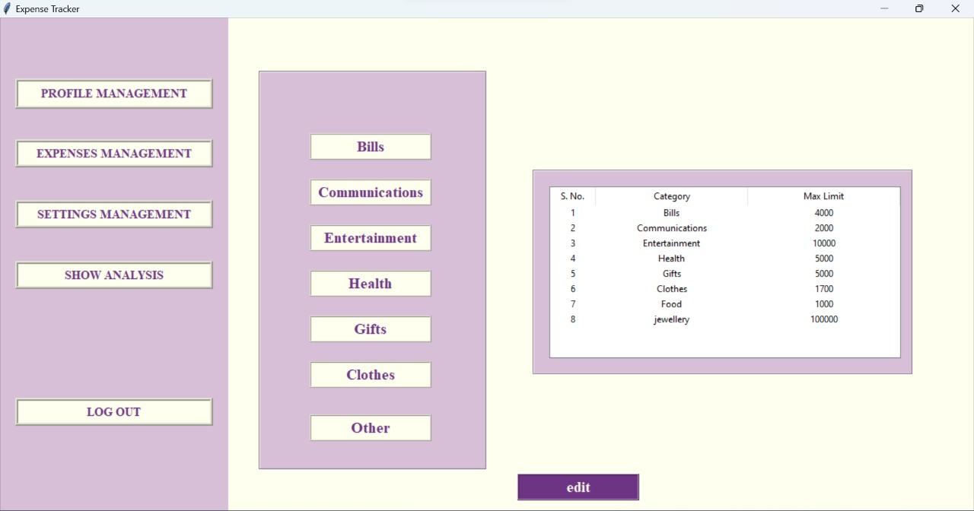

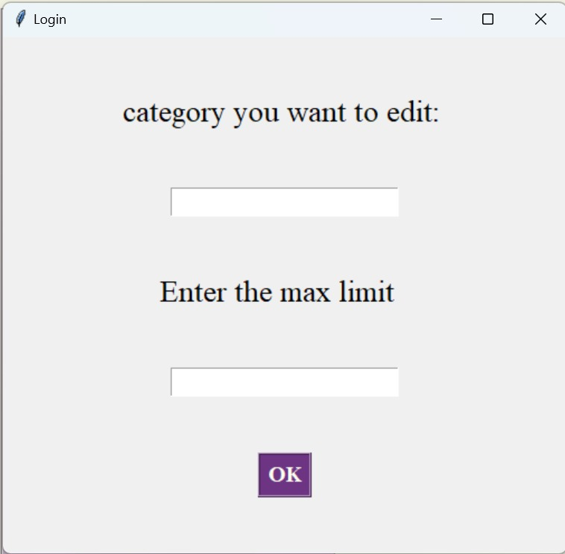

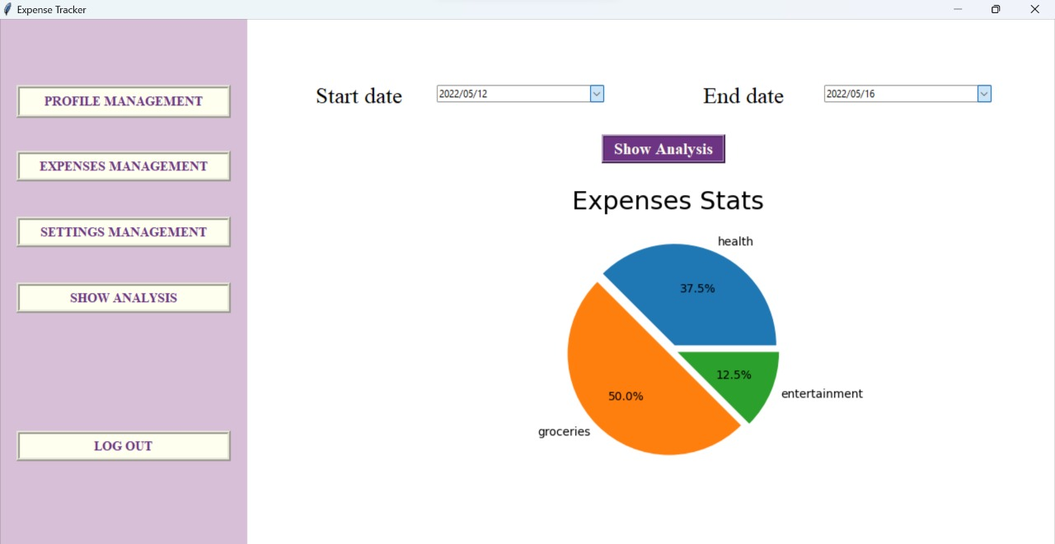

### **1.SPRINT REVIEW**

The sprint review was held on 13-05-2022 and attended by N.Kavya Reddy, M.Preethi Reddy, V.Shravya, Y.Sravya Reddy . Before approving or rejecting product backlog items as noted above, key decisions from the review were:

* We decided to add an option for adding profile photo in profile management page
* We decided to create an alert box to notify If the transaction limit exceeds

### **2.SPRINT RETROSPECTIVE**

The team held a sprint retrospective on 13-05-2022. It was attended by everyone. Key decisions were:

* Edit customer page should be added
* Password should be inserted on add customer page

The team held a sprint retrospective on 7-05-2022. It was attended by everyone. Key decisions were:

* We were able to deliver certain features thanks to our team members contributions.
* The release process has been well documented and ran smoother.